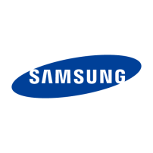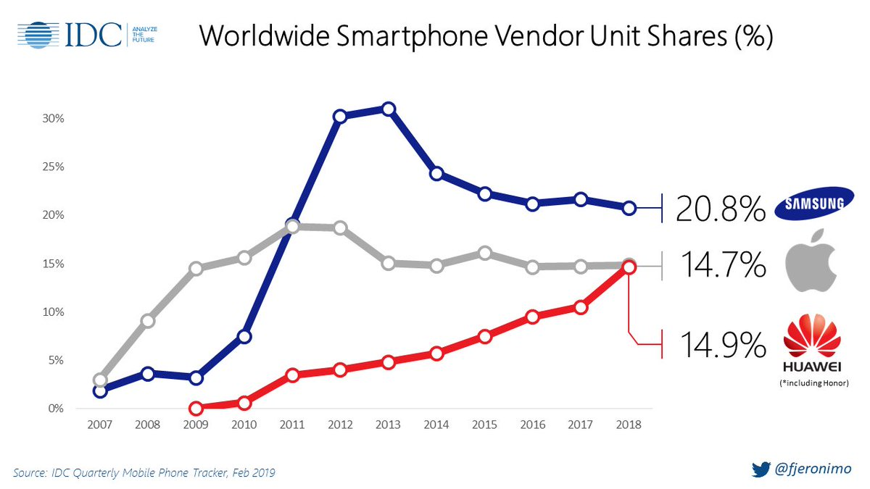Exercise 4: Find a word that fits (noun, verb, preposition, adverb) to complete the presentation of the chart below. **Each verb may be used only once.** *(8pts)*

This from IDC shows the global smartphone shares of Samsung, Apple

and Huawei 2007 and 2018. We can see that, 2007 to 2009,

Samsung’s shares between 2% and 4%. Then they to

a at 30% in 2012 and 2013. However the shares

to 25% in 2014. Then they to

20.8% in 2018.

In comparison, we can see that Apple’s shares to 18%

In 2011 but they started to in 2012 and then at 14.7% until

2018.

As for Huawei’s shares, they to overtake

Apple 0.2% in 2018.